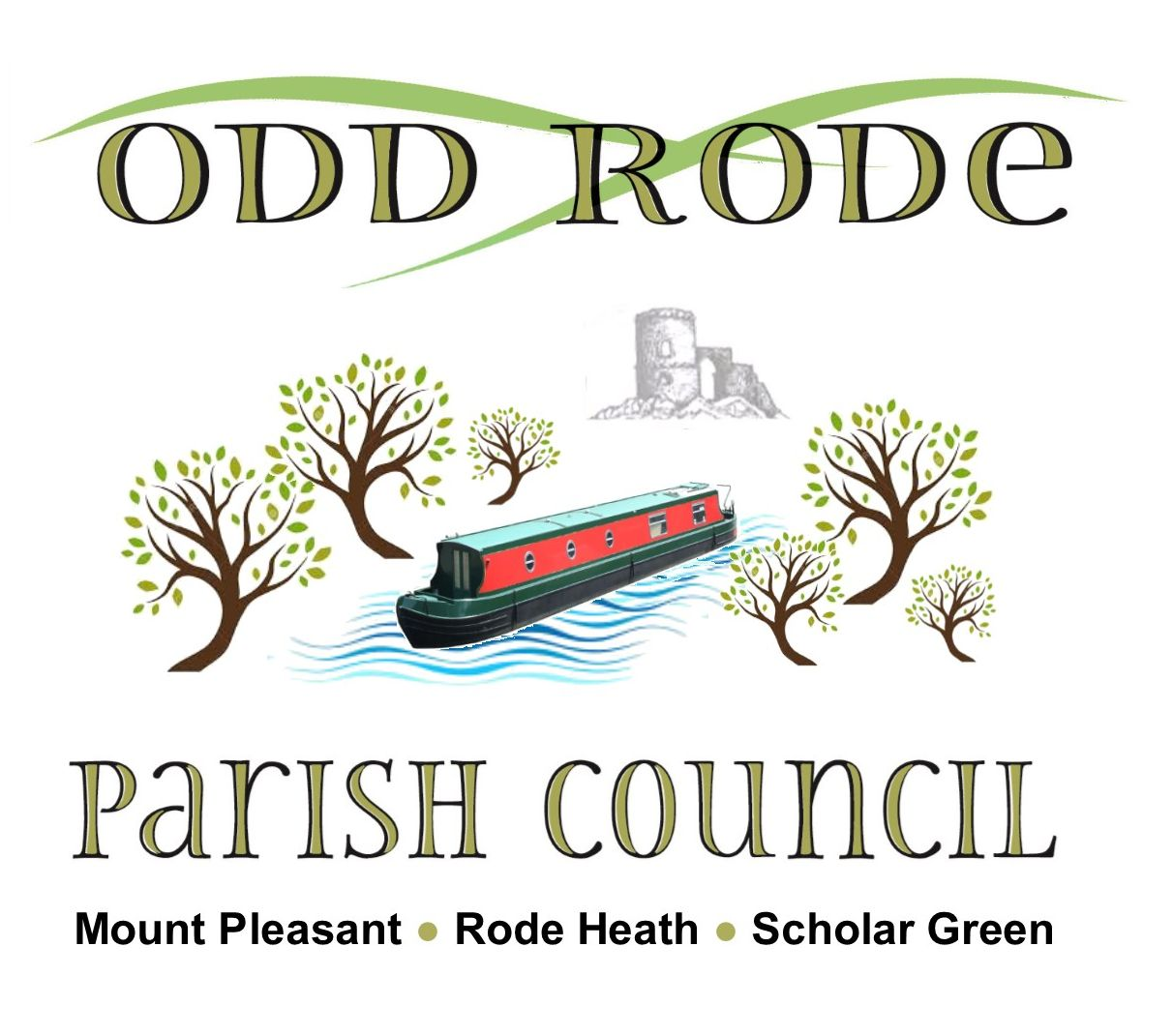
Name of Organisation and contact details (contact person, email and phone number):

Details of grant (amount awarded and purpose for which it was awarded):

Can you confirm that the whole of the grant was spent on the purpose for which it was given?

YES NO
Have you attached copies of accounts, receipts and invoices to support this monitoring form?

YES NO

If you have answered NO to either of the last two questions, please explain why?

Did you need to raise additional funds for this project?

YES NO
If yes, what other funds did you manage to raise and from where?

How did your project meet the Council’s aims & objectives in meeting identified community needs?

Do you have any photographs of the project suitable for inclusion in Parish Council publications?

YES NO
If yes, please send them to oddrodeclerk@gmail.com. If no, would you agree to us sending a photographer to visit the project?

YES NO
Did you include the words ”supported by Odd Rode Parish Council” and/or the Council logo in all publicity material relating to the project?

YES NO

Signed: Position: Date:
THIS FORM MUST BE RETURNED, COMPLETED, WITHIN 9 MONTHS OF THE GRANT AWARD. NO FURTHER GRANTS WILL BE AWARDED UNTIL THIS FORM IS RETURNED COMPLETED.

